**AIM:**  Design NFA using simulator to accept the input string “bbc” ,”c”,and ”bcaaa”.

**INPUT:**

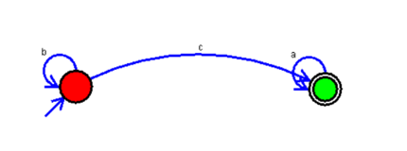

**OUTPUT:**

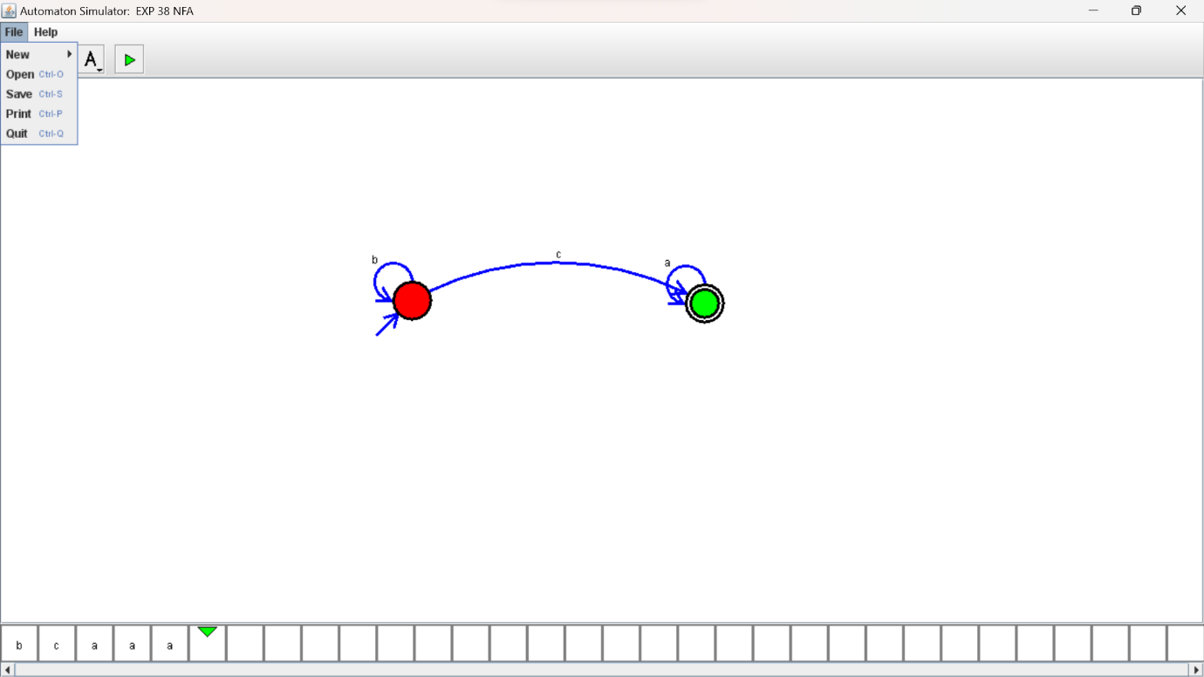

**RESULTS:**

NFA using simulator to accept the input string “bbc” ,”c”,and ”bcaaa”.